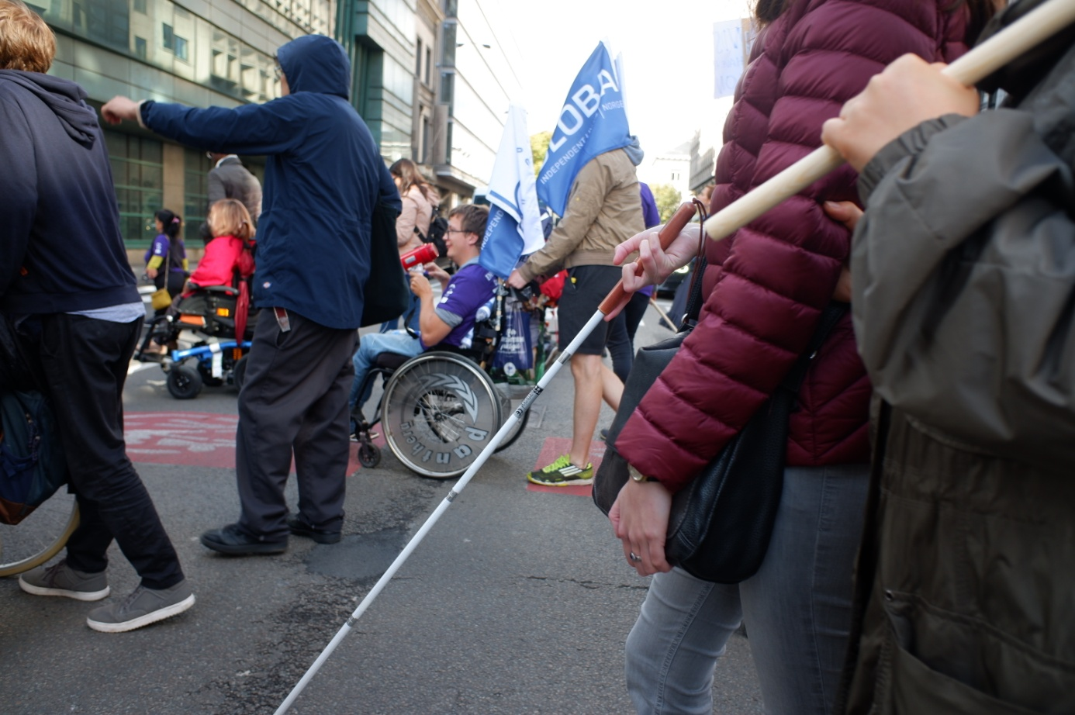
How can we ensure Independent Living for all? - Catering for people with diverse impairments
Webinar organised by the European Network on Independent Living - ENIL
Tuesday 15th September 2020, at 13:00 – 15:00 CEST.
English captioning and International Sign Language will be available
Platform: Zoom (Registration: https://us02web.zoom.us/webinar/register/WN_pkp5s_MkRASwQ4C1R8XTtw)
(Picture shows a white cane user with her PA on the forefront, with wheelchair users and walking people on the background – all marching together during our Freedom Drive 2019)
Background and objectives
After our successful regional members' meeting in Poland in 2019, ENIL is organising a two-day programme of online events on 14-15 September 2020.
The events on the 14th September are for ENIL members only, while the webinar on the 15th September is open to anyone that is interested. The topic of the webinar is “Independent Living for all, and how it is applied for people with diverse impairments”. We have invited a range of speakers to share their experience of Independent Living in a Question and Answer format.
The topic of the webinar was chosen in a survey sent out to members in June. This was the most popular one, most likely because there are so many misconceptions about Independent Living. Many think that the right to Independent Living does not apply to all disabled people or do not understand the barriers faced by people with intellectual disabilities, autism, or others, in living independently. Personal assistance, a key tool for Independent Living, is also misunderstood as only relevant to people with physical disabilities. Given that the Independent Living movement is a cross-disability one, we hope that this webinar will contribute to even more diversity and inclusion in our work.

Speakers
- Magnus Andén and Cecilia Blanck (Sweden) – JAG
- Simone Aspis (United Kingdom) – Changing Perspectives and Free Our People campaign
- Thibault Corneloup (France) – CLE Autistes
- Kristina Dūdonytė (Lithuania) – Independent Living Association
- Jolijn Santegoeds (The Netherlands) – European Network of (ex-) Users and Survivors of Psychiatry
- Mark Wheatley (United Kingdom) – European Union of the Deaf
- Suvad Zahirović (Bosnia and Herzegovina) – Information Center for Persons with Disabilities "Lotos"

Agenda
13:00 – 13:10 Welcome and introduction by the moderator Ines Bulic Cojocariu – ENIL’s Deputy Director
13:10 – 13:50 Discussion with all the speakers on what Independent Living means to them and what are the biggest challenges they face
13:50 – 14:30 Discussion with the speakers on the topics like legal capacity, the role and management of personal assistance, prejudices, de-institutionalisation, what can governments do etc
14:30 – 15:00 Q&A with audience, and closing words by moderator

